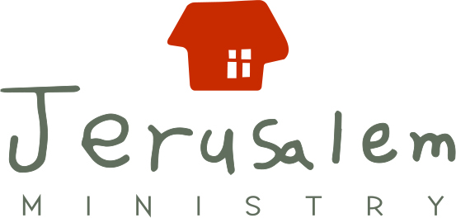

Application for Jerusalem Ministry Summer Internship

Submit to jerusalem.ministry@gmail.com
Insert Digital Picture | Korean Name:  English Name:  Nationality: |  | Gender:
 |  |  | Date of Birth:
 | Occupation or Grade:  Place of Work or School:  Major: |  | Church:  Attendance Length:
Korean Proficiency (underline which applies): none basic vocabulary only
basic conversation fluent

Address: |  | Email: | Contact #:
Approximate dates of summer commitment:

References, including one pastor or leader from your church: (name + contact info)
1.
2.
3.
Do you have any health conditions?
Are you currently seeing a psychologist?
Do you have any allergies (including food allergies)? If “yes,” then please list them:

How did you hear about Jerusalem Ministry?

Previous Experience: (List ministry, mission, work, and volunteer experiences.)

Skills: (Include language abilities.)

Comments:

Date:
Your Testimony: (Tell us about your spiritual history and your current relationship with Christ.)

