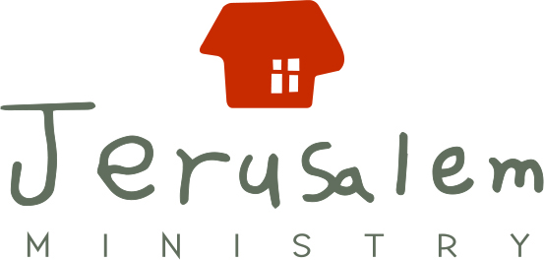

2017 Summer Volunteer Internship

The Purpose
The goal of this internship is to display the love of Jesus to the youth living in Korea’s children’s homes through the avenue of English language education. Through teaching and fellowship, the volunteer will experience everyday life in a Korean children’s home while depending on God’s sufficient provision.

The Experience
- Volunteers will be trained and discipled by the Jerusalem Ministry staff
- Volunteers will serve in pairs and live within a children’s home in Seoul. Their day may include waking with the kids, sending them off to school, helping in the baby room, teaching English in the afternoon and evening, and spending time with the kids (eating with them, playing with them, etc.)
- Volunteers will serve at the home each day except on Sundays.
- Volunteers will teach English in classes of two or three students.
- Opportunities will also be open to teach other subjects (sports, art, music, etc.).
- Volunteers will learn to be dependent on God and His word as they discover how to love God’s children.
- Volunteers will attend the Friday Jerusalem Ministry staff meetings and will also attend New Philadelphia Church’s Sillim campus (www.newphilly.cc) on Sundays.

Volunteer Requirements
- Must be believers of Jesus Christ and must complete and submit the attached volunteer application by April 10th, 2017.
- Must make an approximate two month commitment. Orientation is set as Friday, June 16th. The move-in date will likely be Monday, June 19th (can change depending on the children’s home). We prefer for applicants to commit until August 18th. August 11th will likely be the earliest we can allow a volunteer to end his/her commitment.
- Must have at least conversational Korean speaking ability. Volunteers will be with Korean speakers most of the time.
- Must raise support to cover plane ticket and living expenses (approximately $2300). Living expenses are usually about $400 a month, but any extra money raised can be spent on treating the children to special meals or special activities. Living expenses will include transportation fees (subway/bus/taxi), phone, food (eating out), treating the kids, along with other miscellaneous expenses (toiletries, etc.). We offer help in how to raise support. No part time jobs are allowed for interns.
- Must be dedicated to the children and to the ministry. This is a summer mission trip and it should not be spent to tour, shop, or spend time with relatives. While this can be done before or after the internship, during the two month commitment we require dedication and responsibility to the children’s home, staff and children.

Past Reflections
Past summer volunteer reflections and camp videos: http://www.jerusalemministry.org/content/work/now.html

